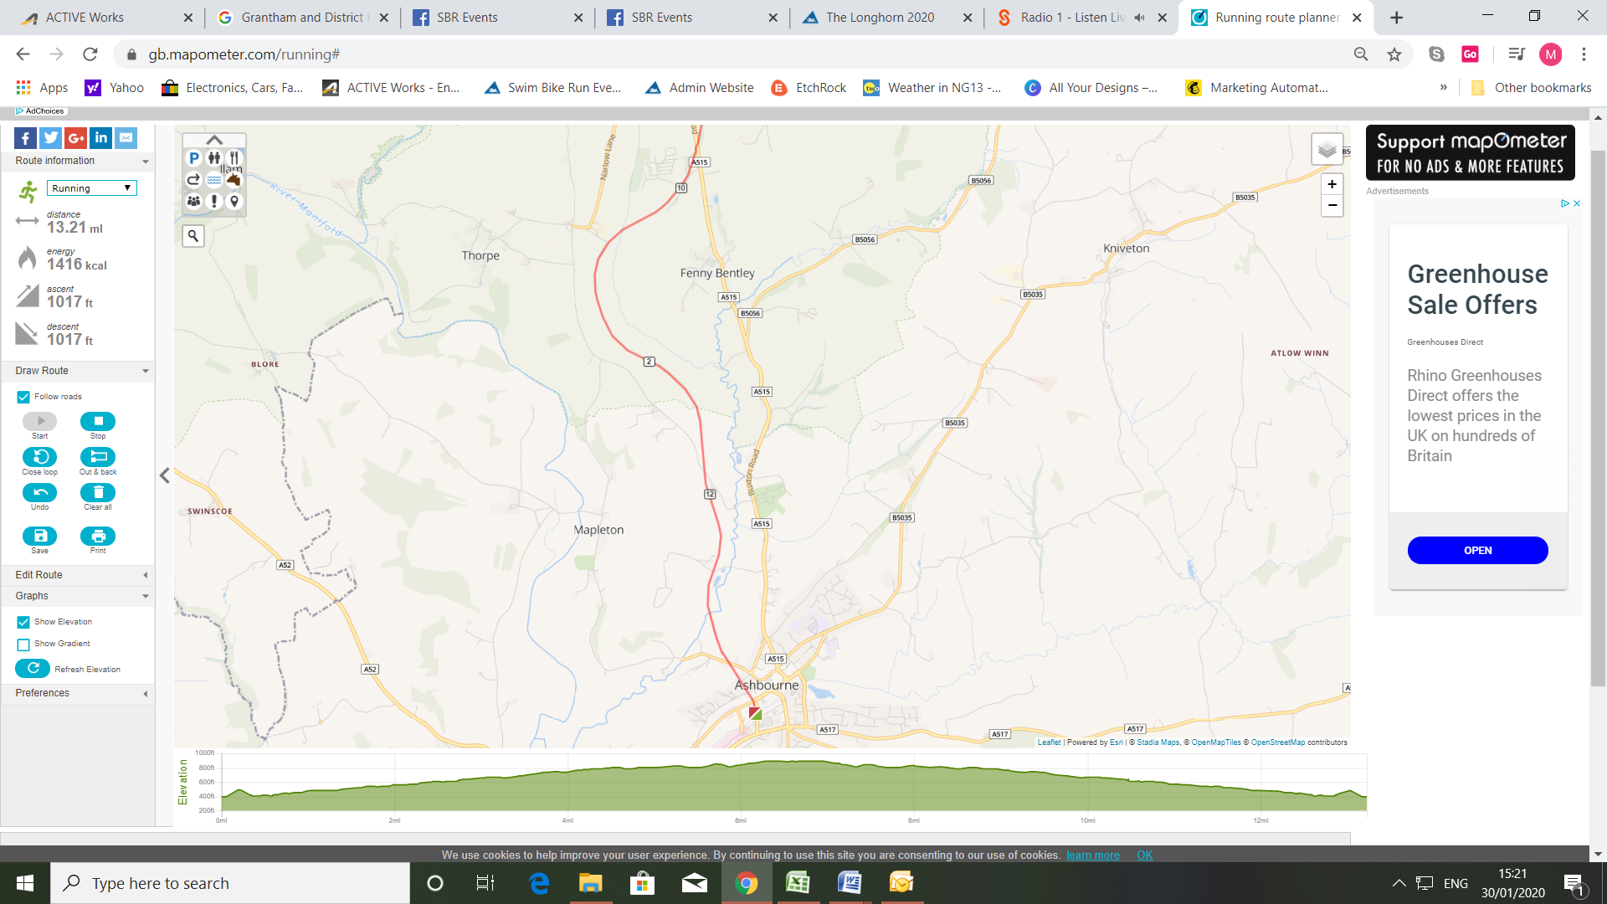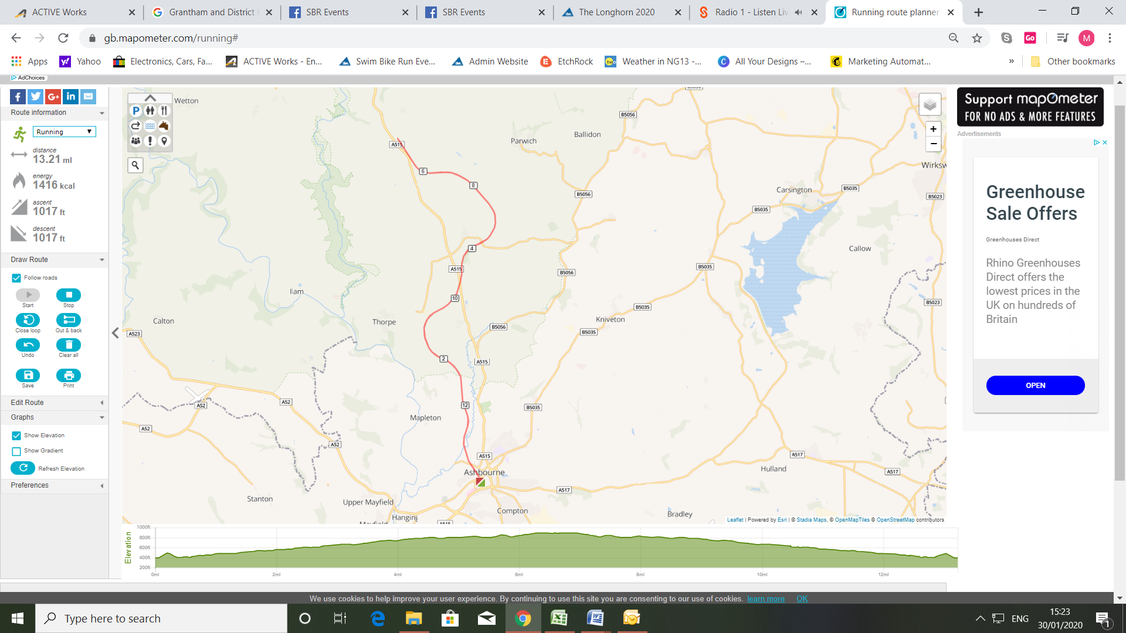

* Distance markers are miles
* Yellow – Turn Points
* Blue – Water stations

Ashbourne Seesaw Route Map

**10m turn point at 5 miles**

**5k turn point at 2.5km**

**HM turn point at 6.6 miles**

**10k turn point at 5km**